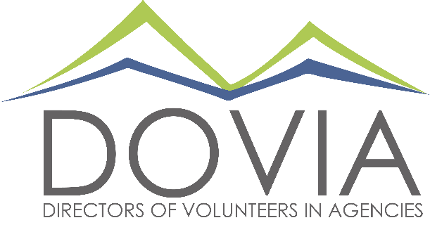

Marketing Volunteer Opportunities
DOVIA strives to make the world a better place by making volunteer engagement professionals – and volunteers – the best that they can be! Join our passionate team to spread the word, better engage our members and recruit new ones, and elevate volunteer engagement as a profession.
Check out these opportunities. Don’t see something on this list, but have a skill? Let us know! We invite you to share any communications and marketing talents you may have to make our mission stronger.

Qualifications: Ideally, we’re looking for folks with some experience in these areas, but avid and proactive learners are also welcome.
Location: All opportunities are flexible in timing and can be done from any location (even and especially over a glass of wine while petting your dog – what glamor!*).

Role | Activities | Estimated Time Commitment
Social Media Guru | - Generate and post content for DOVIA’s Facebook page (baseline = 2-3 posts/week, ideal = 3-4 posts/week).  - Get creative! Post pictures from DOVIA events, promote membership, articles about volunteerism, quizzes or contests.  - Follow all member organizations, as well as partner organizations and anything related to volunteerism. Invite them to follow us!  - Tentative: develop, create and moderate member Facebook group to encourage discussion and networking in between educations sessions. | ~1-2 hours/week
Storyteller | - Capture quotes and pictures of DOVIA events and members.  - Have coffee chats with members and capture their stories of how DOVIA has made a difference to them.  - Gather information and articles on trends in volunteerism, and other stories from the national (and international?) volunteer engagement sector.  - Can be the same role as Social Media Guru or a separate but collaborative one! | ~30 minutes – 1 hour/week
Newsletter Explorer | - Help us determine whether to have an e-newsletter!  - Poll members, do some industry research, figure out whether we should have one and if so, with what frequency and content. | TBD!
Community Ambassador | - Coordinate and offer 3-4 presentations each year to recruit new DOVIA members and elevate the profession of volunteer engagement.  - Could be to universities with nonprofit management type programs, the CO Nonprofit Association, or other entities where we could engage new audiences and raise the visibility of the DOVIA brand! And, of course, elevate the conversation around volunteer engagement as a wonderful career path. | Up to ~6 hours per presentation, including planning and prep
Member Resource Guide | - Our website has gotten some TLC lately, but there’s one section that could still really use some work: the Member Resources page!  - Take on the opportunity to update and enhance this page with the latest resources, education session notes, and links to external partners (like Verified Volunteers, Points of Light, Metro Volunteers, etc.) so this becomes a hotspot for member resources! | ~6 hours?

Interested? Contact Becky Mares, Marketing Committee Chair at bmares@strength.org.

